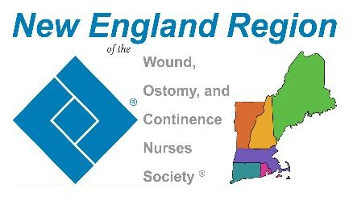

New England Region Youth Rally Scholarship Awards Criteria
January 1- March 15 annually

The New England Region of the WOCN® Society is proud to offer TWO scholarships for a 2 nurses to attend Youth Rally Camp as part of the medical team.
Deadline for submission this year is March 23, 2024

Criteria for application
The applicant must be:
- Certified in wound, ostomy, continence (WOC) nursing
- Current member of the New England Region Chapter
- Not a previous recipient of scholarship from the New England region of the WOCN® Society in the past three years.

Application Process
- Completed application form
- Compose a concise personal statement, limited to 250 words, detailing your motivation to participate in Youth Rally—an overnight camp for kids (www.youthrally.org)—and highlighting the unique qualities that make you the most fitting nurse for this opportunity.
- Please note that scholarship money will be distributed post-camp experience using reimbursement method (save receipts) up to $1,000 per person (please save receipts)

Recipient responsibilities:
- By submitting the application, the applicant is providing written permission for the New England Region WOCN® to place the submitted essay and photo on the New England Region WOCN® website.
- Submit a photo in your Youth Rally T-shirt (no campers), to be posted on website.
- Will be required to submit 3-5 minute video about experience at Youth Rally to be used on social media/website or played at conference. If assistance is needed in creating the media, it will be provided by our comittee.

Please note the following:
- The application deadline is March 23, 2024
- Recipients will be notified April 15, 2024 to give ample time to complete Youth Rally Medical Staff application
- Information potentially identifying the nominee will be redacted for an impartial blind vote by the Membership Committee, one Board member of the New England Region and if needed, a consulting member of Youth Rally staff
- Applicants not receiving a scholarship will be notified in writing via email after the review process.
- Recipient(s) will be notified via phone call and it will be announced on social media (Instagram & Facebook) as well as via email to our membership
- Scholarship recipients will be solely responsible for all federal and or local taxes associated with the scholarship.

NO APPLICATIONS WILL BE ACCEPTED AFTER THE DEADLINE
Applications will be submitted to Leah Abecassis at Leah.Abecassis@childrens.harvard.edu

