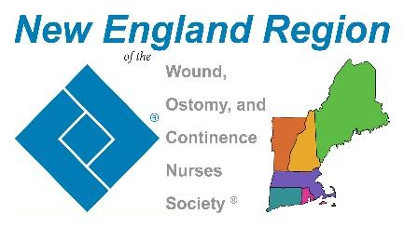

New England Region Educational Scholarship Awards Criteria
Applications open April 1st - October 1st yearly

The New England Region of the WOCN® Society is proud to offer scholarships for:
- Nurses wishing to attend an Accredited Wound Ostomy and/or Continence Educational Program (WOCNEP) and
- Current Certified Wound ,Ostomy and /or Continence Nurses interested in obtaining a Master’s Degree in Nursing, Doctoral Degree, Nurse Practitioner or Clinical Nurse Specialist Certification.
Deadline for submission is October 1st Yearly.

Scholarship Criteria:
- Current active member of the New England Region of the WOCN® Society
- Employed or willing to seek employment within the New England Region in the clinical practice of Wound, Ostomy, Continence Nursing, upon graduation.
- Proof of: Certification in Wound, Ostomy and/or Continence seeking a Master’s Degree in Nursing, Doctoral Degree, Nurse Practitioner or Clinical Nurse Specialist Certification. (If you are accepted but have not yet begun the program at time of submission, or If you are accepted and have already started your program at time of submission, or if you have ended your program within the last 12 months at time of submission)
- OR
- Proof of: Current enrollment in a WOCNEP accredited by the Society or Specialty Course, Certificate of completion from a WOCNEP accredited by the Society or Specialty Course within 12 months.
- Not a previous recipient of scholarship from the New England region of the WOCN® Society in the past three years.

Application Process:
- Completed application form
- Personal statement describing your interest in obtaining certification in the field of Wound Ostomy and/or Continence Nursing or your interest in graduate school and any contributions to the WOCN® Society at the National, Regional or Affiliate level (150-200 word) Participation in WOC organizations, development of educational programs , projects, posters, presentations, research or precepting related to the WOCN discipline.
- Two letters of recommendation from professional associate who has know the applicant for at least one year (a current employer, colleague or mentor is preferred)

Please note the Following:
- The application deadline is October 1, yearly
- Information potentially identifying the nominee will be redacted for an impartial blind vote by the Membership Committee and one Board member of the New England Region
- Applicants not receiving a scholarship will be notified in writing via email after the review process.
- Recipient(s) will be notified and awards presented at the New England Region WOCN® Fall Conference
- Scholarship recipients will be solely responsible for all federal and or local taxes associated with the scholarship.

Recipients responsibilities:
- Winners will be required to submit a photograph and a 150-250 word essay/statement describing their past, current and future contributions to the WOCN® Nursing Specialty Practice.
- The recipient(s) will be asked to join a New England Region WOCN® Committee with a one year commitment.
- By submitting the application, the applicant is providing written permission for the New England Region WOCN® to place the submitted essay and photo on the New England Region WOCN® website.

NO APPLICATIONS WILL BE ACCEPTED AFTER THE DEADLINE
Applications will be submitted to Karen Baggetta at newenglandwocnmembership@gmail.com

