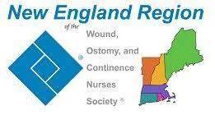
New England Region of WOCN Society®
Youth Rally Scholarship Application

Applications must be received by March 23, 2024
Return the completed application and personal statement to:
Leah Abecassis at Leah.Abecassis@childrens.harvard.edu
Awards will be announced on social media and via email

Full Name:
Mailing Address:
City/State/Zip:
Phone (Work): |  | Phone (Home):
Email:
Date of WOC Certification:
Certification Program:
Member of New England Region of WOCN?: |  | - Yes | - No
Have you participated in the Youth Rally Camp before as a medical professional?
 |  | - Yes | - No
Are you a prior recipient of any scholarships from NER WOCN?
- Yes | - No | If so, which one?
Please attach the following documents to your application:
- CV/Resume | - Personal Statement
I hereby certify that the information on this application and additional documents are true and accurate.

Signature |  | Date
Please note that incomplete applications will not be reviewed.

